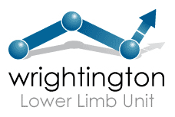
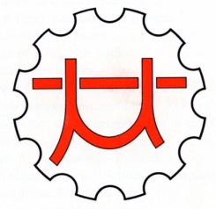
Charnley Low Friction Society - Founded in 1974

All Fellows and Registrars who have worked at Wrightington for six months or more are now able to become Members of the Low Friction Society. Membership is free. The intention is to hold a meeting every two years with a social event in the evening.
The next meeting will be a Combined Meeting with the Wrightington Gold Medal Research Day and Low Friction Society in the Wrightington Conference Centre, Wrightington Hospital with dinner in the evening on:
Friday 19th June 2020
If you wish to join the Low Friction Society please complete the details below and email to Liz Newton at: wrightingtoncourses@gmail.com

Name:
Address:
Email: Phone:
Hospital:
Dates you worked at Wrightington:
Consultants you worked with at Wrightington:

I will/will not be attending the Combined Meeting with the Wrightington Gold Medal Research Day and Low Friction Society and/or Dinner on 19th June 2020
(please delete as applicable).

Wrightington Hospital, Hall Lane, Appley Bridge, Wigan. WN6 9EP
Email: wrightingtoncourses@gmail.com
Tel: 01257 256293

